MAHBUB ALAM Résumé

- CONTACT ADDRESS

Find Me AT: EXIM Islami Investment Ltd.
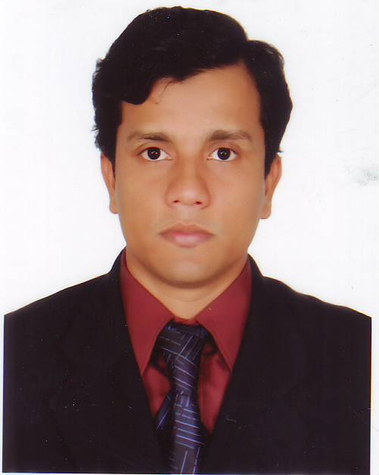
Printers' Building (4th Floor)
5, Rajuk Avenue
Motijheel C/A, Dhaka – 1000
Dhaka. Bangladesh
PABX: +880 2 956 1604, EXT- 112
Cell: +88 01712- 781847
Email: alamrayhan@yahoo.com

- Education:

Professional Courses & Diploma:

ICMAB (institute of cost & management accountant of Bangladesh)
Qualified

ICSB (institute of chartered secretaries of Bangladesh)
Qualified

ICAB (institute of chartered accountant of Bangladesh)
Intermediate (Pursuing Application Level)

BANKING DIPLOMA
DAIB (Institute of Bankers of Bangladesh), DIB (IBTRA)

General Courses:

MBA (finance)
Institute of Business Administration, University of Chittagong, CGPA 3.77 out of 4.00

BBA (honors-finance & banking)
Institute of Business Administration, University of Chittagong, Bangladesh. Completed four years Graduation course and obtained CGPA 3.63 out of 4.00.

LLB (bachelor of laws)
National University of Bangladesh. Second Class.

H.S.C
Govt. Mujib College, Noakahli, Bangladesh. Completed two-years of college in Science. Passed in 2nd Division in 2000.

S.S.C.
Govt A.H.C High School, Noakhali, Bangladesh. Completed ten-years of school in Science. Passed in 1st Division in 1998.

- Working Experience:

COMPANY SECRETARY (From August 2011 to Date)
EXIM Islami Investment Ltd. (Merchant Banker)
A subsidiary of Exim Bank.
Printers' Building (4th Floor) 5, Rajuk Avenue, Motijheel C/A, Dhaka – 1000
- Company Secretarial Activities.
- Liaison with Register of Joint Stock Companies and Firms.
- Preparation of Financial Statements.
- Preparation of various reports as per management demand.
- Market Monitoring
Management Trainee Officer (From August 2009 to August 2011)

Merchant Banking Division
Export Import Bank of Bangladesh Ltd.
Printers' Building (4th Floor) 5, Rajuk Avenue, Motijheel C/A, Dhaka - 1000

- Maintaining Complete Accounts.
- Compliance with local regulatory authority.
- Advisory Services to clients.
- Portfolio management services.
- Back office maintenance and CDBL related activities
Senior Officer (Listing & Prelisting Dept) (From June 2008 to 31 July 09)

Chittagong Stock Exchange Ltd.
Barek Building, Agrabad, Chittagong.

- Analyzing IPO documents and placing comments there on for listing new companies.
- Full support in selecting CSE 30 (top) companies.
- Index Adjustment & Disseminating information in monthly publication of CSE.
- Remarkable Attributes:
- Accustomed with securities related laws & regulations.
- Fluent in English
- Excellent communication skill
- Excellent Team Cohesiveness
- Can Work Under Pressure
- Quick Learning Capability
- Good Adaptation, Good Listener

- Training Received:

- 5 days training on “Investment & Merchant Banking” at BAB.
- 20 days Training on “General Banking” at EBTI.
- 04 days workshop on “Effective Business Communication” at CSE.
- Basic computer courses on operating system and application software.

- Computer Literacy:

Operating System: Windows 95, 98 ME and Windows NT platforms including Windows 2000 and Windows XP

Application Packages: Worked extensively with MS Word, MS Excel (Office XP package), Utility and trouble shooting software and Internet applications

- Personal Details:

Name : MAHBUB ALAM
Father's Name : KHURSHID ALAM
Mother's Name : LUTFUN NAHAR
Date of Birth : 9th September 1982
Place of Birth : Noakhali
Nationality : Bangladeshi by birth
Religion : Muslim
Marital Status : Married
- ReferEEs:

- Abu Hena Md. Mohsin
Vice President
EXIM Islami Investment Ltd.
Printers Building, 4th Floor, Motijheel, Dhaka.
Phone: 01730069696

- Dr. Fazlul Haque
Director (Ex)
Chittagong Eye Infirmary.
Phartuli , Chittagong.
Bangladesh.
Phone:01712216644

Signature
(Mahbub Alam)

